WEEK 6

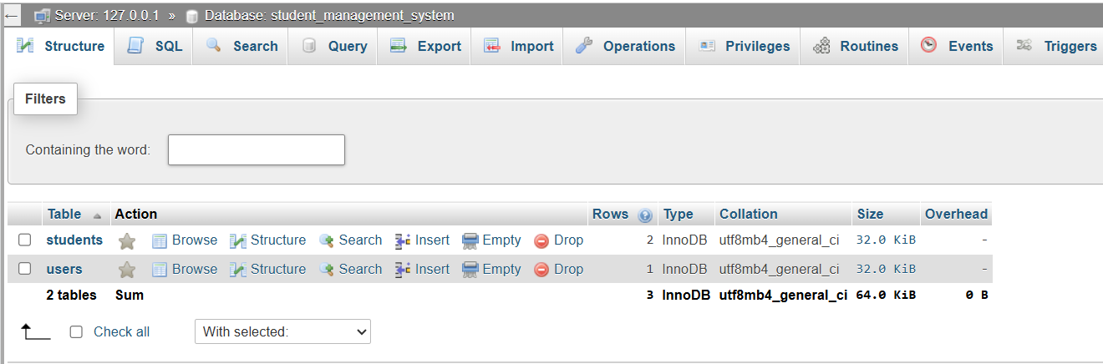
Figure 1 Empty student table

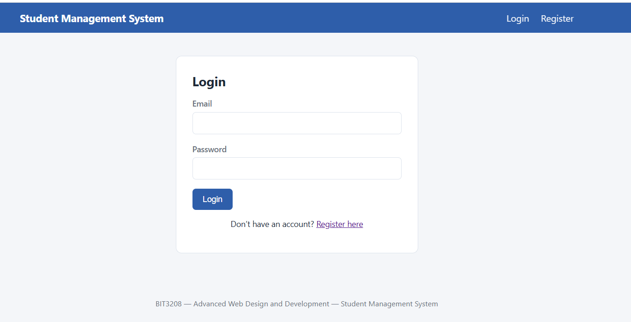
Figure 2 registration form

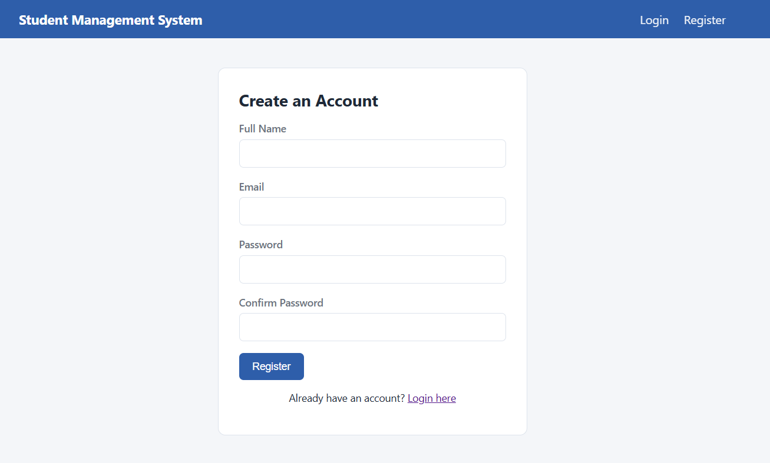
Figure 3 login form

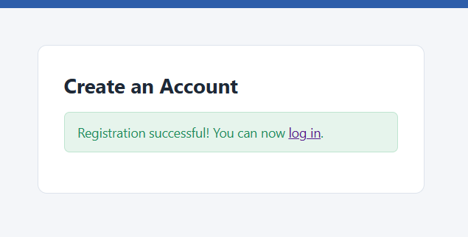
Figure 4 successful registration message

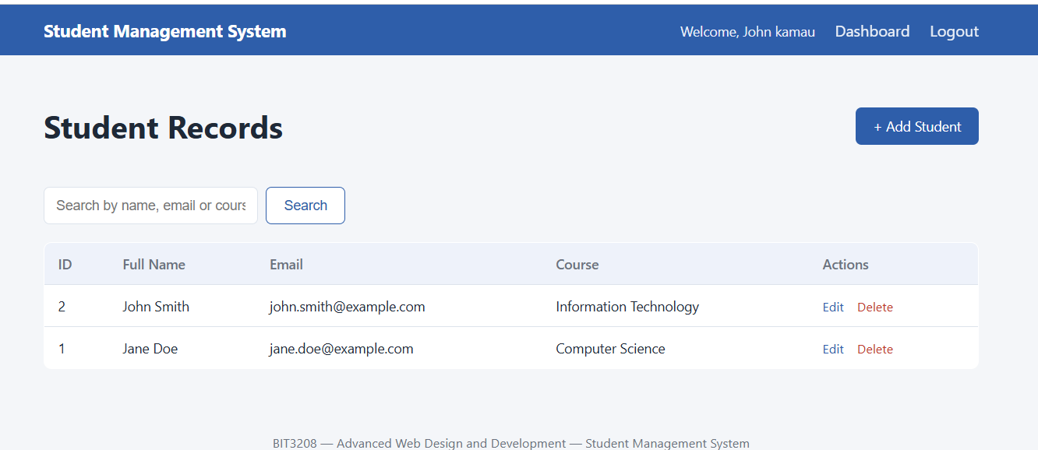
Figure 5 dashboard with the student lists

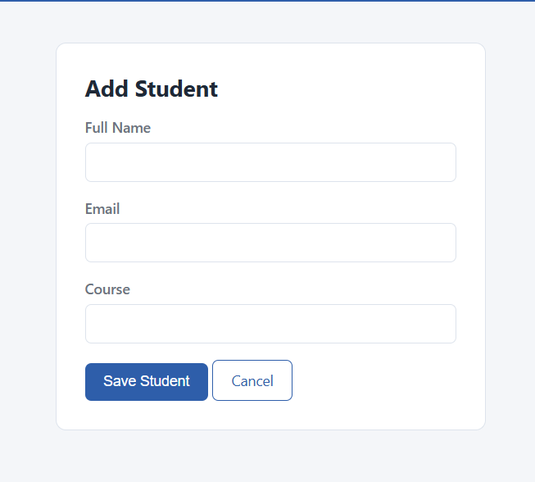
Figure 6 Student form
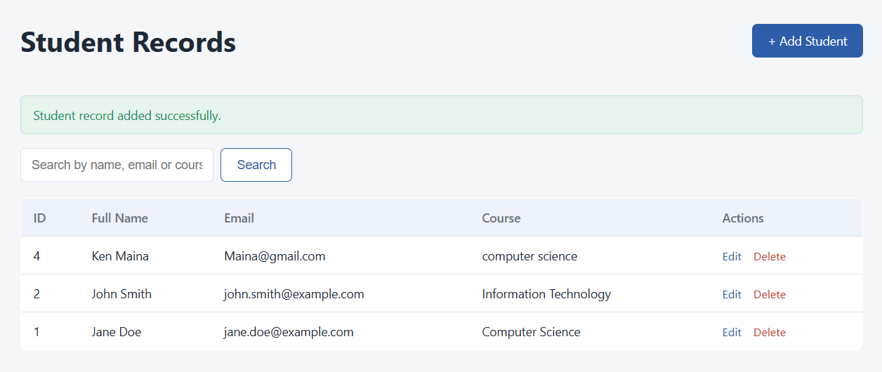
Figure 7 successful added student
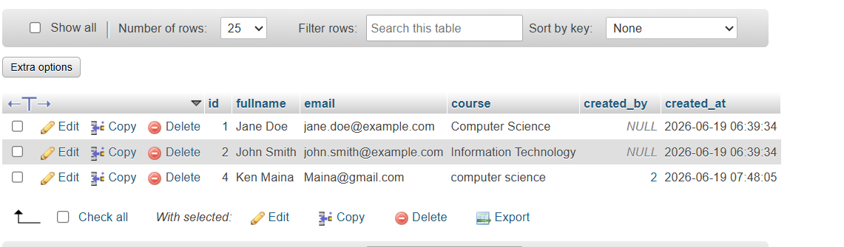
Figure 8 successfully saved in the database

